To: | Cabinet
Date: | 17 September 2025
Report of: | Clive Tritton, Director of Economy, Regeneration and Sustainability
Title of Report: | Project approvals and delegations for Cave Street affordable housing development

Summary and recommendations
Decision being taken: | This report seeks project approval and delegations to progress the development of affordable homes at Cave Street. This includes delegated authority to enter into build contracts and other necessary agreements and associated development costs, virement of HRA capital funds and the approval to commence the process regarding the appropriation of land from the General Fund (“GF”) to the Housing Revenue Account (“HRA”) (changing the statutory basis on which it is held by the Council).
Key decision: | Yes
Cabinet Member: | Councillor Linda Smith, Cabinet Member for Housing  Councillor Ed Turner, Cabinet Member for Finance and Asset Management
Corporate Priority: | More Affordable Housing
Policy Framework: | Housing and Homelessness Strategy 2023 to 2028

Recommendation(s): That Cabinet resolves to:
- Grant project approval to finalise the scheme design, to the proposals to enter into build contracts and any other necessary agreements or contracts and incur associated development cost spends, as set out in this report, and within the allocated HRA capital budgets and business plan, for the purpose of delivering more affordable housing in Oxford;
- Delegate authority to the Director of Housing, in consultation with the Cabinet Member for Affordable Housing; the Head of Financial Services/Section 151 Officer; and the Council’s Monitoring Officer, to enter into build contracts and any other necessary agreements or contracts to facilitate the development within the identified budget, for the provision of additional affordable housing;
- Grant approval for a virement within the HRA capital budget for scheme costs of £5.9 million. The virement will be from the “Properties purchased from OCHL” (Oxford City Housing Limited) purchase line into a new scheme line to be profiled to match the build programme across the four years from 2025/26 to 2028/29;
4. | Recommend to Council the appropriation of the land owned by Oxford City Council (OCC) at Cave Street from the General Fund (GF) into the Housing Revenue Account (HRA).

Appendix No. | Appendix Title | Exempt from Publication
Appendix 1 | Financial Information Cave Street | This information is exempted from publication under Schedule 12A to the Local Government Act 1972 on the following basis:  Commercial Sensitivity
Appendix 2 | Planning considerations & risk | This information is exempted from publication under Schedule 12A to the Local Government Act 1972 on the following basis:  Commercial Sensitivity

Introduction and background
- The Council continues to develop a supply programme to deliver more affordable housing through multiple work streams, including the delivery of homes through the Council’s housing company – OCHL (Oxford City Housing Limited); direct delivery by the Council; joint ventures; regeneration schemes; acquisitions; and enabling activity with Registered Providers, community-led housing groups, and other partners.
- The Council seeks to deliver over 1,600 affordable tenure homes across the next four years (to March 2029), with at least 850 of those at the most affordable Social Rent level. Projections at the time of writing will deliver 1,500 homes across this period, and additional sites and developments are required to meet these targets and address housing need within the city.
- Officers continue to review opportunities to bring forward the development of further affordable homes to increase the supply available to help meet Oxford’s housing needs. This might take the form of developing more new homes; acquiring property to use as affordable housing; or switching tenures to improve affordability and access to these homes.
- This report identifies a further opportunity for the delivery of more affordable homes at Cave Street. It sits alongside two other reports (acquisition of Elsfield Hall and Knights Court into the HRA).
- These three new opportunity sites are being brought forward to collectively deliver 83 or more new units in the affordable housing programme. They have been appraised jointly and on an individual basis and meet HRA financial parameters (see ‘Financial Implications’ section). They also present an opportunity to deliver affordable housing to help meet the 1,600 homes target across the 4-year MTFP, rather than at the back end of the development pipeline programme in 2031/32.

Scheme information
- This report concerns Cave Street – a vacant site in the St Clements area, the site was an employment/ new business starter premise (Standingford House) - now demolished (as end of life). Access is onto Cave Street, a small residential street.
- In December 2022, planning consent was granted for the erection of a new 2-3 storey office building. This was to be funded via the LEP, but the funding opportunity ended in 2023, and replacement funding to deliver an employment site is not expected.
- The site is owned by OCC in the General Fund commercial portfolio.
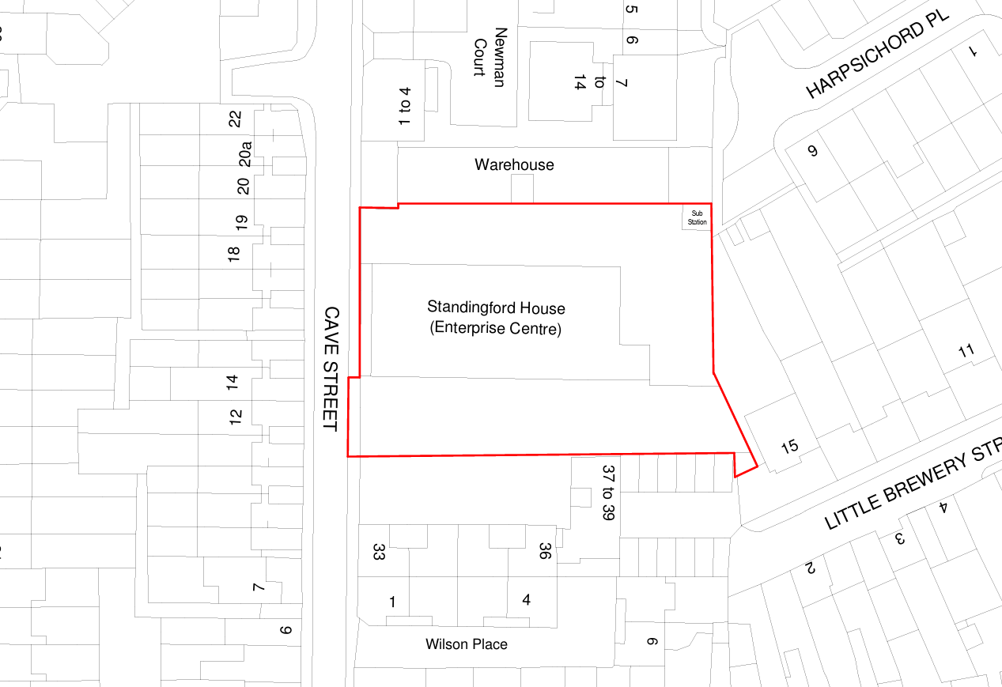
Image 1: Red line drawing of site (Standingford House now demolished)
- The proposal is for a 100% affordable housing development, and the site is considered to have capacity for 19 homes, though this needs to be agreed through the planning process and will be subject to design development and viability considerations. The intention is to match the massing height and footprint to the existing planning approval for commercial use.
- The tenure mix has yet to be finalised, though initial testing includes ten units for Social Rent and nine units for Affordable Rent (to support the delivery of one bed units to meet needs) but capped at LHA rates in line with the Council’s Tenancy Strategy. Again, the final tenure strategy will be subject to design development and viability considerations. The table below sets out an early indication of the likely mix (of property sizes and tenures) that the site is considered capable of taking in physical design terms, and in terms of ensuring the financial viability of the scheme.

Size | Social Rent | Affordable rent | Total | %
1 bed | 10 | 9 | 19 | 100%
2 bed | 0 | 0 | 0 | 0%
3 bed | 0 | 0 | 0 | 0%
4 bed | 0 | 0 | 0 | 0%
Total | 10 | 9 | 19
Percentage | 53% | 47%

- The sizes of the individual homes have also yet to be confirmed, but the Council's ambition is to prioritise 1-bed homes to directly respond to the housing need and the Council would be seeking a deviation from the usual planning mix to support this objective. These will always meet ‘Nationally Described Space Standards’, but in addition, the Council would seek to ensure that one bed flats are for two people. Any two bed homes should accommodate for four people; three bed homes are for five people (i.e., two double bedrooms and a single); and so forth.
- To ensure that 5% of the affordable homes meet the M4 (3) “Wheelchair Standard” (to be adapted/ adaptable for households with mobility needs), it is expected that two homes will meet this requirement. The design and allocation of this property has yet to be completed but will be part of the planning submission.
- The proposed delivery model is for the HRA direct delivery, under which the Council retains full ownership of the land and delivers the scheme through its Housing Revenue Account. OCHL will be appointed as the Council’s development agent via a Development Services Agreement (DSA). There will be no disposal of the land; instead, the Council will grant a licence to the building contractor to carry out the development works on the Council-owned land. The DSA will require OCHL to procure the grant of this licence as part of its role in managing the delivery of the scheme on the Council’s behalf along with procuring and appointing a contractor.

Alternative Options Considered
- The option of not proceeding with Cave Street as a development opportunity would mean that the site does not realise its full potential to deliver affordable housing to help meet the 1,600 homes target across the 4-year MTFP. The current programme for Cave Street targets a project completion at the end of 2027 – providing an opportunity to deliver homes relatively quickly, compared with other larger pipeline sites.
- Disposal to a private developer is also a consideration. While this could potentially generate a capital receipt, it would limit the Council’s ability to ensure delivery of genuinely affordable housing and control over design quality and sustainability standards and will not necessarily contribute to the delivery of more affordable housing.
- Whilst Planning permission for a commercial development has been granted, due to build-cost increases and uncertainty of the office-letting market, the delivery of the scheme is unviable for the Council.
- Only ‘core’ affordable tenures have been modelled – Social Rent (as the OCC priority) and Affordable Rent (as cross-subsidy). Initial feasibility studies show that a small scheme of at least 13 x 2-bed flats (part-two, part-three storeys) would be possible using the existing footprint and mass of the current office planning consent. Financial modelling shows that a solely social rented scheme can just pass the HRA financial parameters but would only support a land value of £330k, so is not possible.

Financial implications
- Introduction of this site into the development pipeline (alongside the two other opportunity sites at Elsfield Hall and Knights Court) is contingent on re-shaping of the existing OCHL development programme to release necessary funding for the developments. This will require a virement to be approved within the HRA capital programme from the current “Properties purchased from OCHL” to the new schemes as discussed in this paper.
- The current OCHL programme review is necessary to address an existing budget pressure (attributed to delays and build cost inflation), and an adjustment is proposed to introduce additional market sale units to cover-off the budget pressure and allow for a programme contingency to be introduced. The re-shaping will then also release funding for these three new pipeline schemes. As such, the budget required for the new opportunity sites will be contained within the existing development budget envelope and will not require an increase to the existing budget.
- A separate paper will be presented to Cabinet to detail the proposed reshaping of the existing programme, as part of the initial budget reports for 2026/27 & the MTFP.
- This report seeks the required delegations to further develop the programme of affordable housing supply. The decision to proceed with any purchase or development will be supported by a development scheme appraisal/ financial modelling to ensure that the agreed financial parameters and requirements are met.
- The financial appraisal for Cave Street has established a proposed HRA capital budget for scheme costs of £5.9 million which includes the appropriation value of the land to the HRA. A budget virement from the “Properties purchased from OCHL” purchase line into a new scheme line is required to match the build programme across the four years from 2025/26 to 2028/29. Further financial details are provided in confidential Appendix 1.

Legal issues
- Section 122 of the Local Government Act 1972 provides a general power to the Council to appropriate land from one statutory purpose to another where the land in question is no longer required for its current purpose. In terms of process, case law has established that appropriation must involve more than a mere decision to hold for the particular land for another purpose. The Council must consider whether the land is no longer needed in the public interest of the locality for the purpose for which it is held.
- This report proposes bringing a vacant commercial site which is no longer required for its original purpose into use as affordable housing.
- To facilitate the proposed housing development, the land must be transferred from the General Fund (“GF”) to the Housing Revenue Account (“HRA”). This report seeks Cabinet’s recommendation to Council for the appropriation of the land at Cave Street from the GF to the HRA.
- In accordance with clauses 4.5 (8), (9) and (10) and (11) of the Constitution, Cabinet is empowered to recommend to Council: transfers of assets between the general fund and housing revenue account, agree transfers between cost centres of over £250,000 provided that they are consistent with the policy framework, give project approval for projects of £750,000 or over and award contracts over £750,000.
- Pursuant to section 9E(3)(c) of the Local Government Act 2000, Cabinet may delegate its functions to officers. Accordingly, Cabinet is asked to delegate authority to the Director of Housing, in consultation with the Cabinet Member for Affordable Housing, the Head of Financial Services/Section 151 Officer, and the Council’s Monitoring Officer, to enter into agreements including the DSA, licence, build contracts, and any other necessary legal agreements or contracts to facilitate the development of affordable housing within the identified budget and land identified in this report.
- Procurement of goods and services for the purpose of developing homes must be carried out in accordance with the Council’s Constitution, Contract Rules, procurement procedures and in compliance with the Procurement Act 2023 (or any successor legislation), including adherence to transparency, fairness and best value principles.
- The proposals set out in this report fall within Council’s statutory powers including the power to provide and manage housing through the HRA. The general power of competence under the Localism Act 2011 and the Local Authorities (Land) Act 1963 enables the Council to develop land it already owns. The appointment of OCHL as development agent via a DSA may rely on the teckal exemption, provided the legal criteria are met. The procurement of the DSA must still be carried out in accordance with the Procurement Act 2023, where applicable, and the Council’s Constitution.
Level of risk
- No planning permission is currently granted on the site, and further design development work is required to establish the proposed scale, massing and quantum of proposed units. Due diligence has been carried out however to identify and mitigate delivery risks associated with a new development. The existing planning consent establishes the principle of development on the site and the planning documentation provides a great level of detail about the site’s opportunities and risks. Whilst the existing consent provides details of what may be acceptable to the LPA, it is noted that any future application will need to assess the site to review its suitability for residential development, and in line with current regulatory standards.
- Further detail on the Principle of Development has been included in Appendix 2.

Equalities impact
- There are no adverse impacts in undertaking this activity, with the potential to improve provision for persons in housing need, through the provision of more affordable and accessible housing to better meet client needs.
Carbon and Environmental Considerations
- All development schemes delivered by OCC/OCHL are subject to high sustainability standards with the expectation that they exceed statutory (building) standards.

Report author | Dave Scholes
Job title | Affordable Housing Supply Corporate Lead
Service area or department | Economy, Regeneration and Sustainability
Telephone | 01865 529123
e-mail | Dscholes@oxford.gov.uk

